Task 1: How phone connects to Instagram
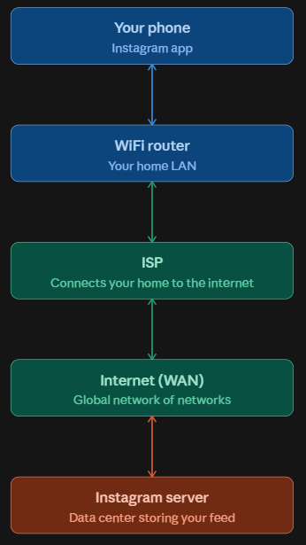
That diagram shows the full path: your phone talks to the WiFi
router over your home LAN, the router hands the request to
your ISP, the ISP routes it across the internet (WAN), and it
finally reaches Instagram's server — which sends the response
back the same way. Each arrow is two-way because every step
involves both a request going out and data coming back.

Task 2: Everyday Network Devices & Network Classifications

Device | Network Type | Purpose
Smartphone | LAN/WAN | Connects to Wi-Fi or mobile network to access the Internet
Laptop | LAN/WAN | Connects to a local Wi-Fi network and Internet
Smart TV | LAN/WAN | Connects to Wi-Fi for streaming online content
Smartwatch | PAN | Connects to a smartphone using Bluetooth
Wi-Fi Router | LAN/WAN | Connects local devices and provides Internet access

Task 3: Internet vs Intranet

- The Internet is a globally accessible, public network of interconnected computer systems communicating via standard TCP/IP protocols. Anyone with an ISP connection can view public resources. For example, when I use college Wi-Fi to access Instagram, Google, or YouTube, I am using the Internet.
- An Intranet is a restricted, private network accessible exclusively to authorized internal users within a specific organization (such as a university or company). For example, student or company portal where peoples can check attendance, examination results, assignments, or notices.
- Example: College Wi-Fi likely gives two things at once. When any student log into the student portal to check attendance, grades, or timetables, you're on the college's intranet — only students and staff with credentials can reach it, and it's not visible to the outside world. But when you use the same Wi-Fi to open Instagram or Google, that traffic leaves the campus network and travels over the internet to reach servers anywhere in the world.

Task 4: Data Flow During an In-App Search (Zomato)

- When open Zomato and type a restaurant name into search Tapping Search triggers the app to package the search query into an encrypted HTTPS request over the smartphone's Wi-Fi or 4G/5G interface.
- The packet travels across the local router/cell tower through the ISP's routing backbone to reach the closest Zomato Edge CDN/API Gateway.
- The gateway terminates SSL, verifies authentication, and routes the search parameters to microservices and database clusters that execute the query.
- The database compiles matching restaurant lists, serializes them into a JSON response, and sends the payload back along the reverse network path.
- The smartphone network adapter unpacks the incoming IP packets, and the app interface renders the restaurant results onto your screen.

